Project Report

On

“Predicting Disease by Symptoms”

Spring 2023 CPSC 531-03 22145

Advanced Database Management

Spring, 2023

Under Guidance of

Prof. Tseng-Ching James Shen

Department of Computer Science



California State University

Fullerton, CA - 92831 May 2023 Prepared By:

Sri Datta Venga S (885176917) sridattavenga14@csu.fullerton.edu

Table of Contents

1. Introduction............................................................................................3
2. Functionalities....................................................................................... 3
3. Dataset………………………………………………………………………………4
4. Architecture & Design (Technology and Tools Used) .................................6
5. Minimum System Requirements................................................................... 6
6. GitHub Location of Code....................................................................... 6
7. Deployment Instructions............................................................................ 7
8. Steps to Run the Application........................................................................ 15
9. Test Results................................................................................................ 15
10. Conclusion...................................................................................... 17

# Introduction

People presently suffer from a variety of ailments as a result of their surroundings and lifestyle choices. As a result, disease prediction at an early stage has become a key obligation. Doctors, on the other hand, find it difficult to make precise forecasts based on symptoms. The most difficult challenge is precisely predicting illness. The accurate and prompt investigation of any health-related concern is crucial for disease prevention and treatment. The normal way of diagnosis may not be sufficient in the case of a serious illness.

The creation of a Disease Symptoms Prediction based on machine learning (ML) algorithms for sickness prediction could aid in more accurate diagnosis than present approaches. We developed a disease prediction system using Supervised machine learning techniques.

# Functionalities

* Cluster Creation with 3 Server Nodes:

Using the Google Cloud Service creating a Dataproc cluster with the desired number of worker nodes. Set the appropriate machine types and configurations based on your workload requirements.

* Storage Bucket Creation:

Using the Google Cloud create a storage bucket. Ensuring that the bucket name is globally unique.

* Importing Data to the Cluster and bucket:

To import dataset from internet on to our Hadoop cluster from Hadoop cluster to google storage bucket. We use two commands.

1, wget https://d37ci6vzurychx.cloudfront.net/misc/taxi+_zone_lookup.csv;

2, gsutil cp taxi+_zone_lookup.csv gs:// rs-bucket1-dataproc/Data; • Jupyter Notebook Integration:

Launching a Jupyter Notebook server on the master node of the Dataproc cluster.

Interacting with the Jupyter Notebook interface to write and execute PySpark code.

* Data Processing using PySpark and Visualization Libraries:

Utilizing PySpark powerful distributed computing capabilities to process the data. Applying transformations and actions on the DataFrame to manipulate, filter, aggregate, join, or transform the data as per requirements.

Use visualization libraries like Matplotlib and Seaborn to create meaningful visualizations of the data.

we're using the k-nearest neighbors (KNN) algorithm to classify the diseases based on the symptoms provided. First , we import the KNeighborsClassifier class from the sklearn.neighbors module. Then, we create an instance of this class with a parameter n_neighbors set to 5. This means that the KNN algorithm will classify each data point based on the 5 closest neighbors to it.

# Dataset

Reference Link -https://www.kaggle.com/datasets/itachi9604/diseasesymptom-description-dataset

Raw Data-

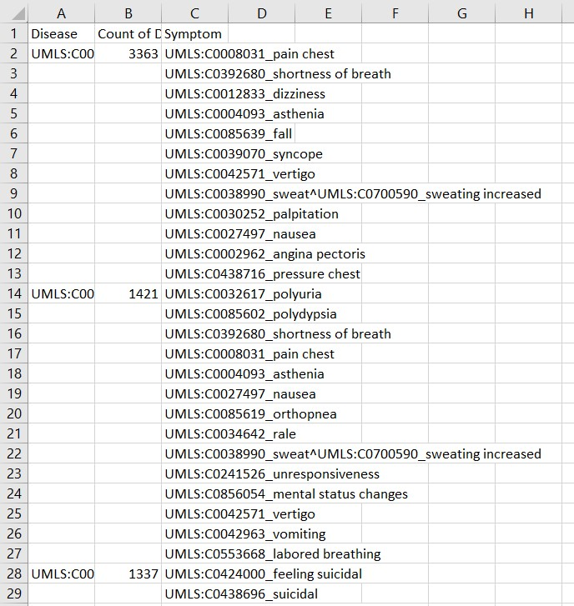

By splitting the data into separate train and test datasets, the train dataset is used to train or "teach" the model by adjusting its parameters based on the input data and known output values. The test dataset, on the other hand, is used to assess how well the trained model performs on unseen data.

Train data-

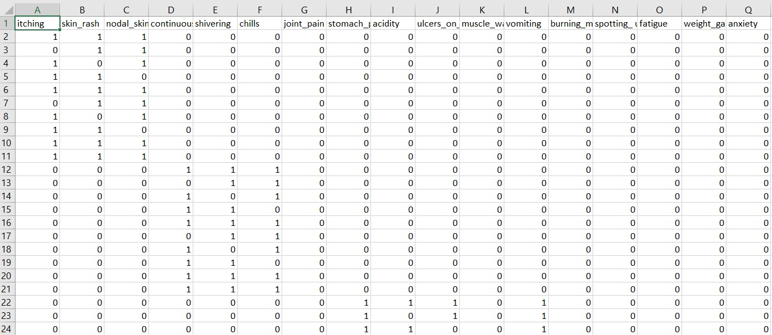

Test data-

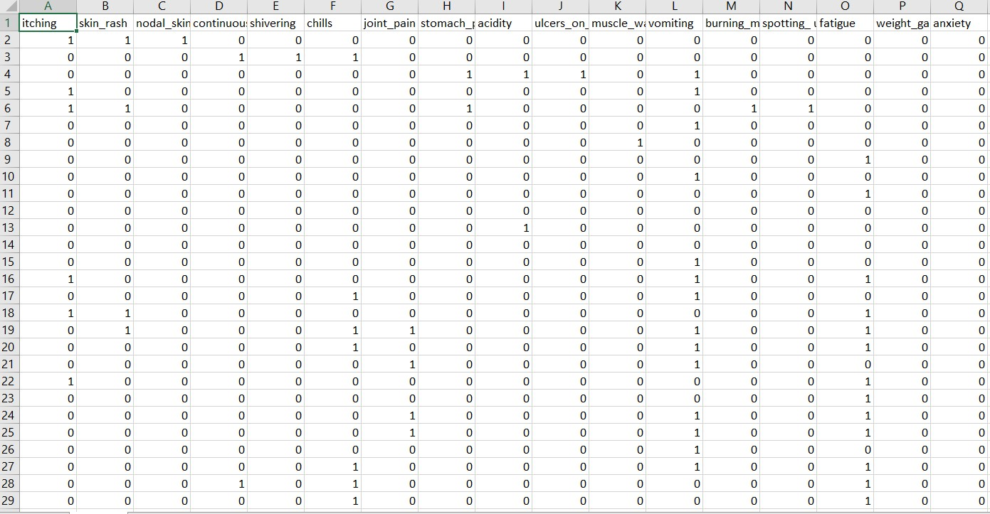

# Architecture & Design

**Tools and technologies used –**

* Google Cloud Service (Dataproc)
* Hadoop Cluster
* Google storage bucket
* Jupyter notebook
* Pyspark
* ML algorithm
* Matplotlib
* Seaborn
* Vector assembler
* NumPy  pandas

# Minimum System Requirements

Every system that is planned to be a part of the cluster must satisfy the following hardware requirements:

* Google cloud service Account
* 1.5 GB RAM (2GB recommended)
* 20 GB Disk Space
* Hypervisor to support virtualization

# GitHub Location of Code



[Disease prediction using symptoms ADBMS-final-project](https://github.com/sri-datta/ADBMS-final-project)

# Deployment Instructions

Dataproc is fully managed big data cluster or big data as service provider.

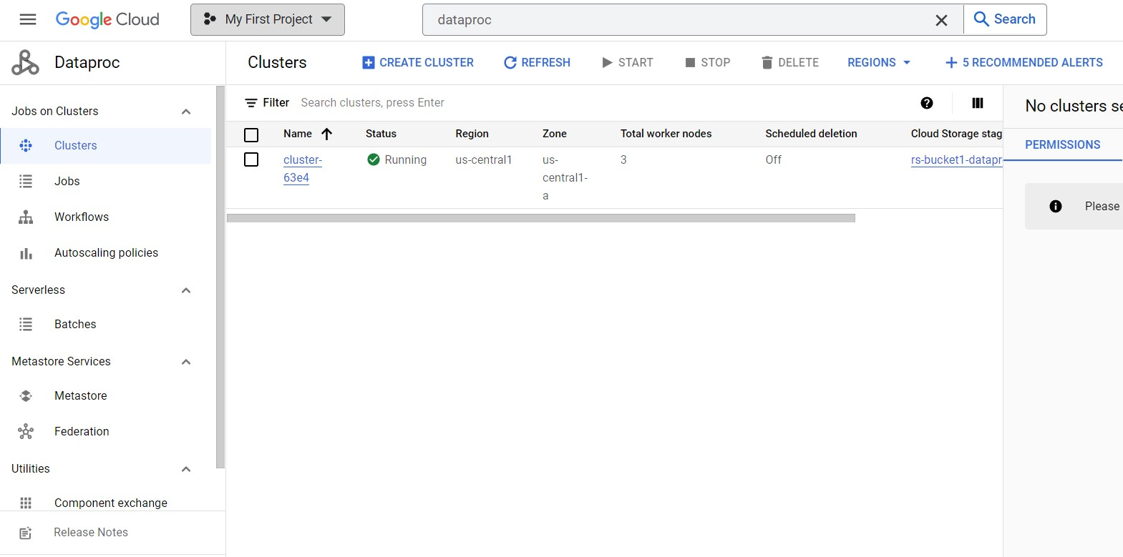

1-Creating a cluster.

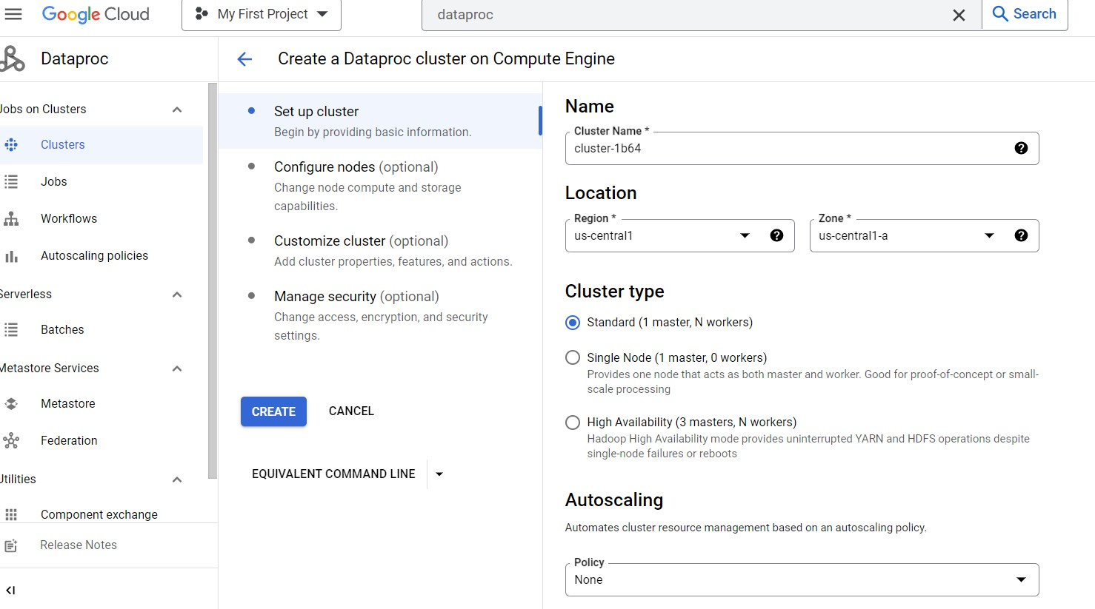

Our project has 3 worker node Hadoop cluster.

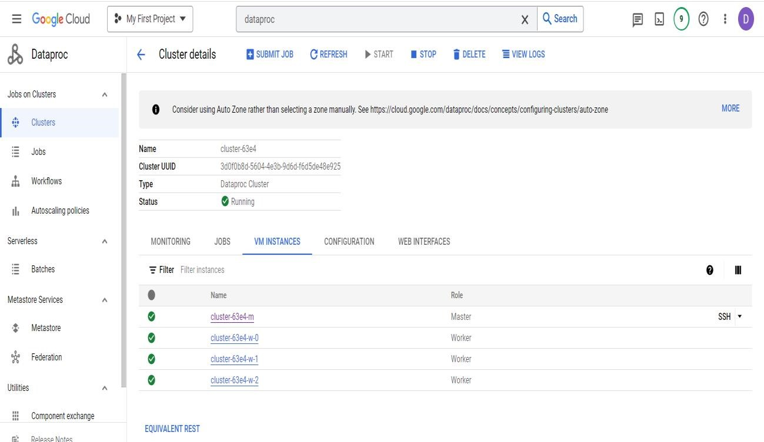

Creating google storage bucket.

* We create bucket to save pyspark code and dataset to process the data.

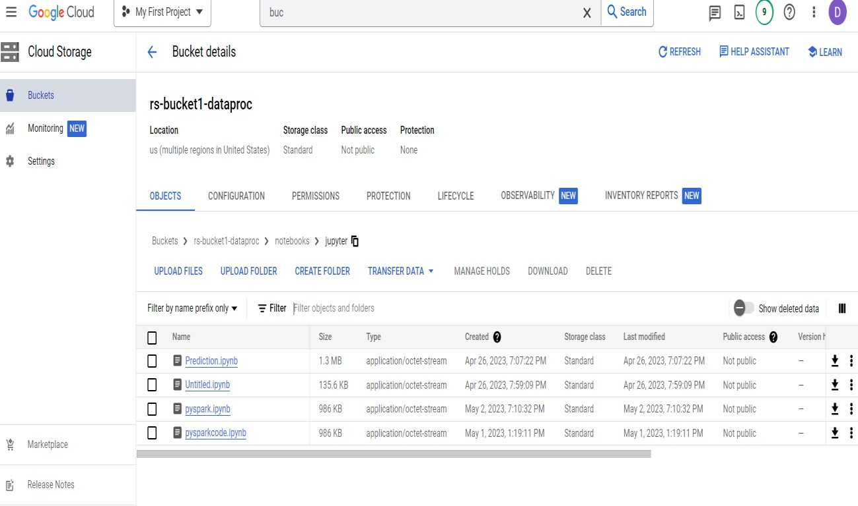

We started setting up the Hadoop cluster and then we connected our Hadoop cluster through jupyter notebook interface.

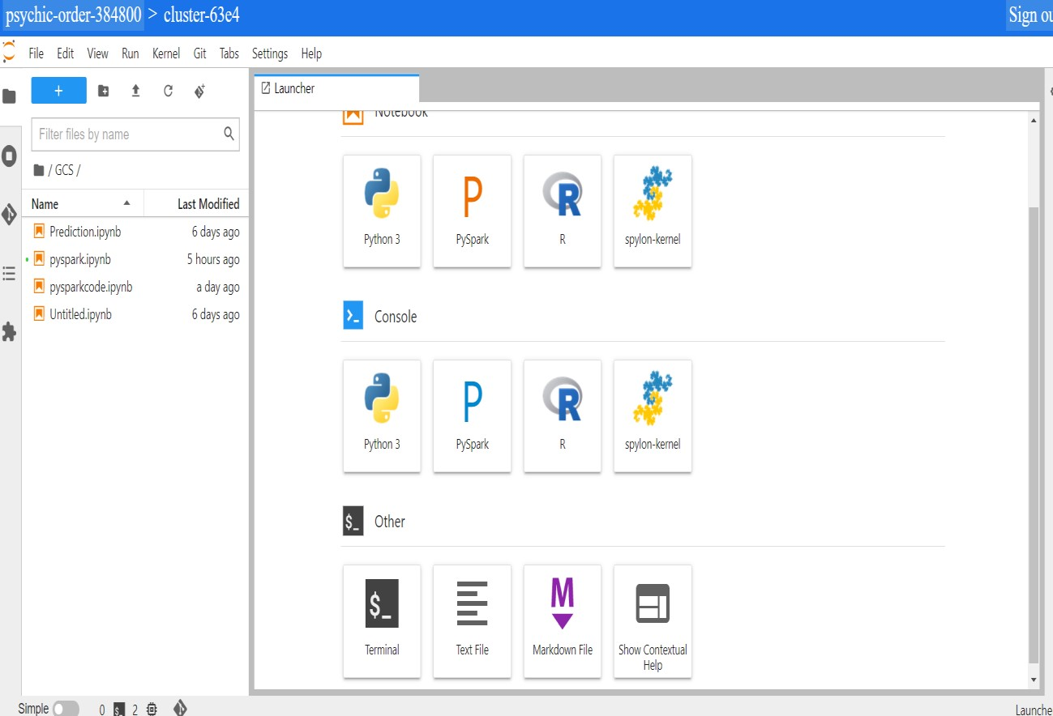

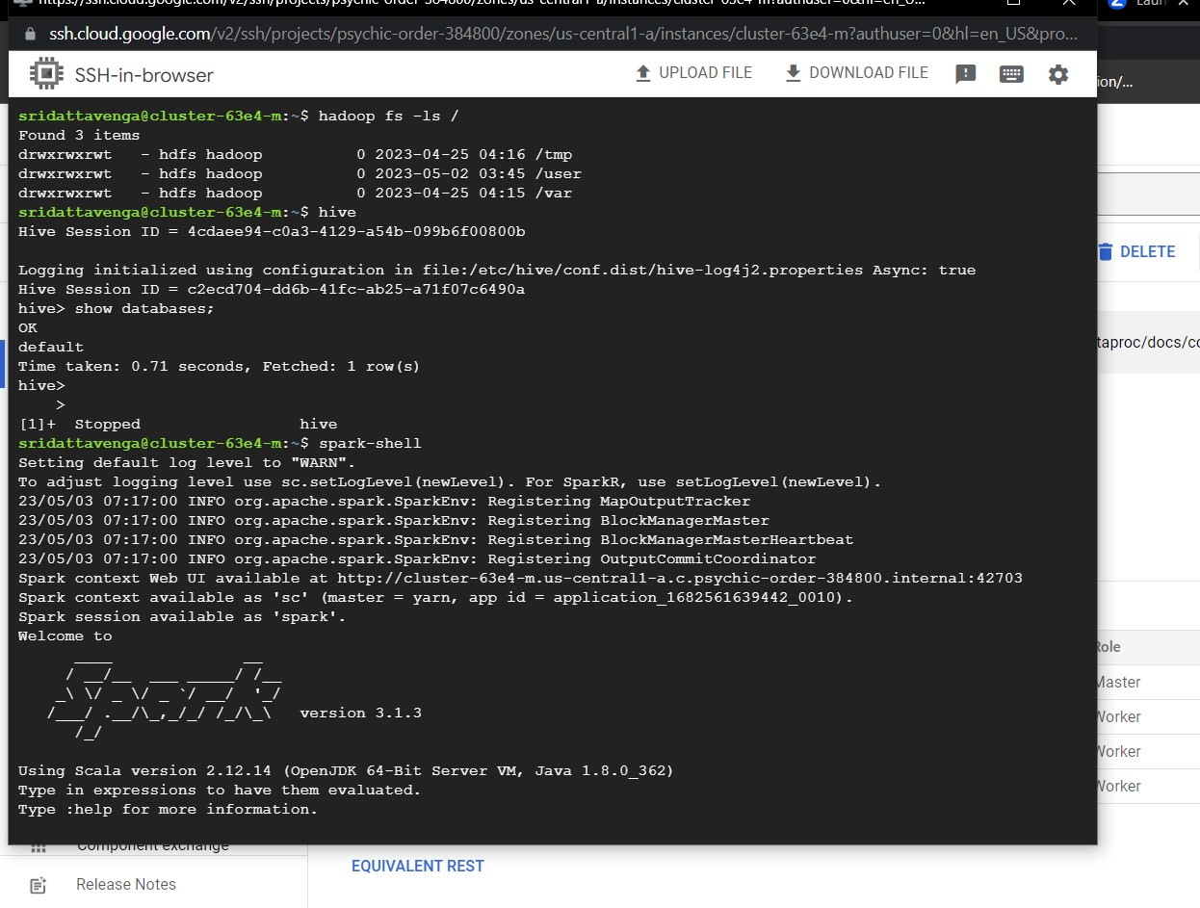

Now, we have to import datasets from the internet into the Hadoop cluster on google cloud on Dataproc and then process data with jupyter notebook.

To import a dataset from the internet onto our Hadoop cluster from the Hadoop cluster to the Google storage bucket. We use two commands.

1, wget https://d37ci6vzurychx.cloudfront.net/misc/taxi+_zone_lookup.csv;

2, gsutil cp taxi+_zone_lookup.csv gs:// rs-bucket1-dataproc/Data;

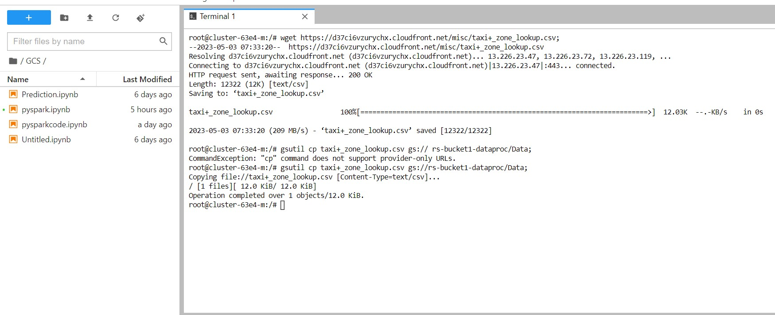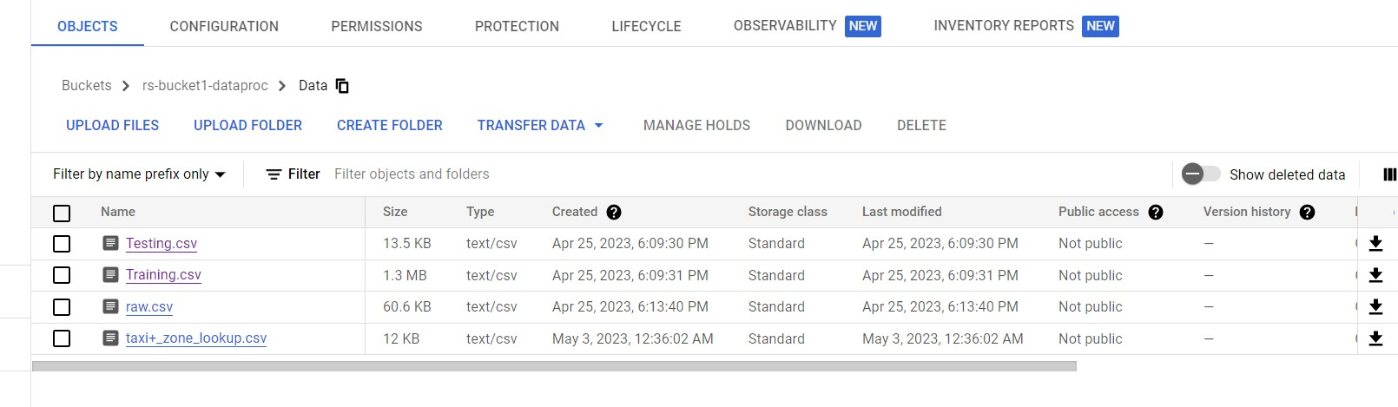

Analyzing data using pyspark through jupyter notebook interface.

* PySpark code to read a CSV file stored in Google Cloud Storage and load it into a DataFrame.

Importing the required module

Creating a SparkSession

Reading the CSV file

Configuring Spark SQL

Displaying the first few rows of the DataFrame from pyspark.sql import SparkSession

# Creating a SparkSession

spark = SparkSession.builder.appName("ReadCSV").getOrCreate()

# Reading the CSV file

df = spark.read.format("csv").option("header", "true").load("gs://rsbucket1-dataproc/Data/Training.csv")

spark = SparkSession.builder.config("spark.sql.debug.maxToStringFields", 100).getOrCreate()

# Displaying the first few rows of the DataFrame df.show()

❖ Reading the training CSV file from GCS bucket:

train_df = spark.read.format("csv").option("header", "true").load("gs://rs-bucket1-dataproc/Data/Training.csv")  Reading the testing CSV file from GCS bucket:

test_df = spark.read.format("csv").option("header",

"true").load("gs://rs-bucket1-dataproc/Data/Testing.csv")

Importing the required modules: import matplotlib.pyplot as plt import seaborn as sns

Visualizing the value counts using a countplot:

sns.set_theme(style="darkgrid") plt.figure(figsize=(12, 30)) plt.xticks(rotation=90)

sns.countplot(y="prognosis", data=train_df.toPandas())

This sets the plot style, adjusts the figure size, and rotates the x-axis labels. Then, it creates a countplot using seaborn's countplot() function, with the "prognosis" column as the y-axis and the "train_df" DataFrame converted to a Pandas

DataFrame using toPandas().The code visualizes the distribution of values in the "prognosis" column using a horizontal bar plot (countplot) for the training DataFrame.

In PySpark, a VectorAssembler is a feature transformer that combines a given list of columns into a single vector column. The resulting vector column can be used as input for machine learning algorithms.

from pyspark.ml.feature import VectorAssembler

Modeling using the K-Nearest Neighbors (KNN) algorithm for classification.

* importing the necessary library
* Creating a KNN classifier object
* Splitting the data into training and testing sets
* Fitting the KNN classifier to the training data
* Making predictions
* Printing the prediction results
* Computing the accuracy of the model

# Modelling

from sklearn.neighbors import KNeighborsClassifier knn = KNeighborsClassifier(n_neighbors = 3) # k = 5 x_train, y_train = train_df.loc[:,train_df.columns != "prognosis"], train_df.loc[:,"prognosis"]

x_test, y_test = test_df.loc[:,train_df.columns != "prognosis"], test_df.loc[:,"prognosis"] knn.fit(x_train, y_train) prediction = knn.predict(x_test)

print("Prediction list: {}".format(prediction[0:50])) print("With KNN (K=5) accuracy is: ",knn.score(x_test, y_test)) **Output:**

Prediction list: ['Fungal infection' 'Allergy' 'GERD' 'Chronic cholestasis

' 'Drug Reaction'

'Peptic ulcer diseae' 'AIDS' 'Diabetes ' 'Gastroenteritis'

'Bronchial Asthma' 'Hypertension ' 'Migraine' 'Cervical spondylosis'

'Paralysis (brain hemorrhage)' 'Jaundice' 'Malaria' 'Chicken pox'

'Dengue' 'Typhoid' 'hepatitis A' 'Hepatitis B' 'Hepatitis C'

'Hepatitis D' 'Hepatitis E' 'Alcoholic hepatitis' 'Tuberculosis'

'Common Cold' 'Pneumonia' 'Dimorphic hemmorhoids(piles)' 'Heart attack' 'Varicose veins' 'Hypothyroidism' 'Hyperthyroidism' 'Hypoglycemia'

'Osteoarthristis' 'Arthritis' '(vertigo) Paroymsal Positional Vertigo'

'Acne' 'Urinary tract infection' 'Psoriasis' 'Impetigo'

'Fungal infection']

With KNN (K=5) accuracy is: 1.0

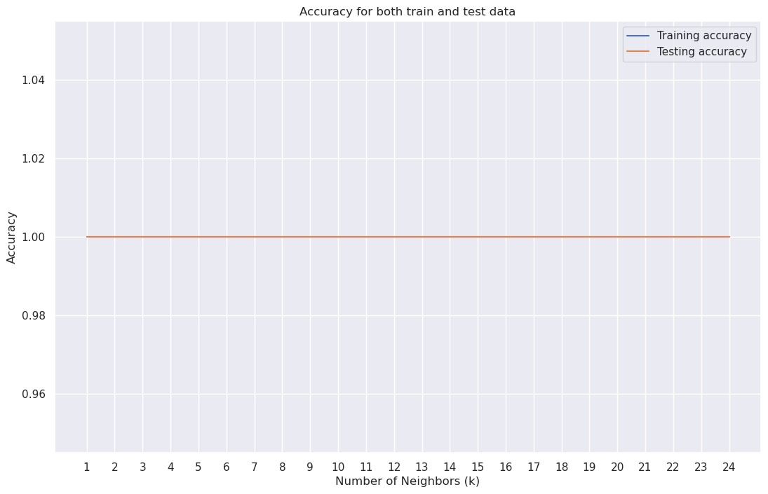

A Decision Tree Classifier is another type of machine learning algorithm used for classification tasks. The accuracy of the decision tree classifier on the test data is 0.9761904761904762, which means that it correctly predicted the diagnosis of 97.6% of the patients in the test set.

from sklearn.tree import DecisionTreeClassifier dt = DecisionTreeClassifier(random_state = 42) dt.fit(x_train, y_train)

dt.predict(x_test) dt.score(x_test, y_test) **Output:**

0.9761904761904762

# Steps to Run the Application

To run the application, select the cluster and run the cluster and then go to web interface and select the jupyter select the notebook files and run all run cells on jupyter notebook and see the results.

# Test Results

* we're using the k-nearest neighbors (KNN) algorithm to classify the diseases based on the symptoms provided.
* First, we import the KNeighborsClassifier class from the sklearn.neighbors module. Then, we create an instance of this class with a parameter n_neighbors set to 5. This means that the KNN algorithm will classify each data point based on the 5 closest neighbors to it.
* Next, we split the training and testing data into separate data frames, with the x_train and x_test data frames containing all columns except the "prognosis" column, which is used as the target variable in our classification. The y_train and y_test data frames contain only the "prognosis" column.
* We then fit the KNN algorithm to the training data using the fit() method. Finally, we use the predict() method to make predictions on the testing data and print out the first 20 predictions. We also calculate the accuracy of the model using the score() method, which compares the predicted values to the actual values in the testing data set. In this case, the accuracy is 1.0, indicating that the model is predicting the correct diagnosis for all the cases in the testing data set.

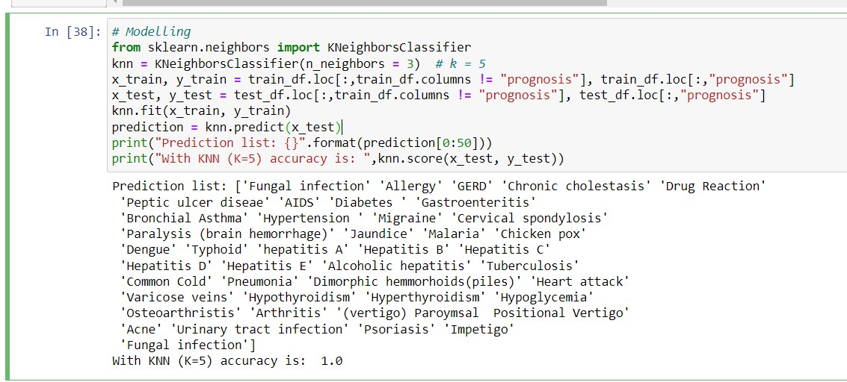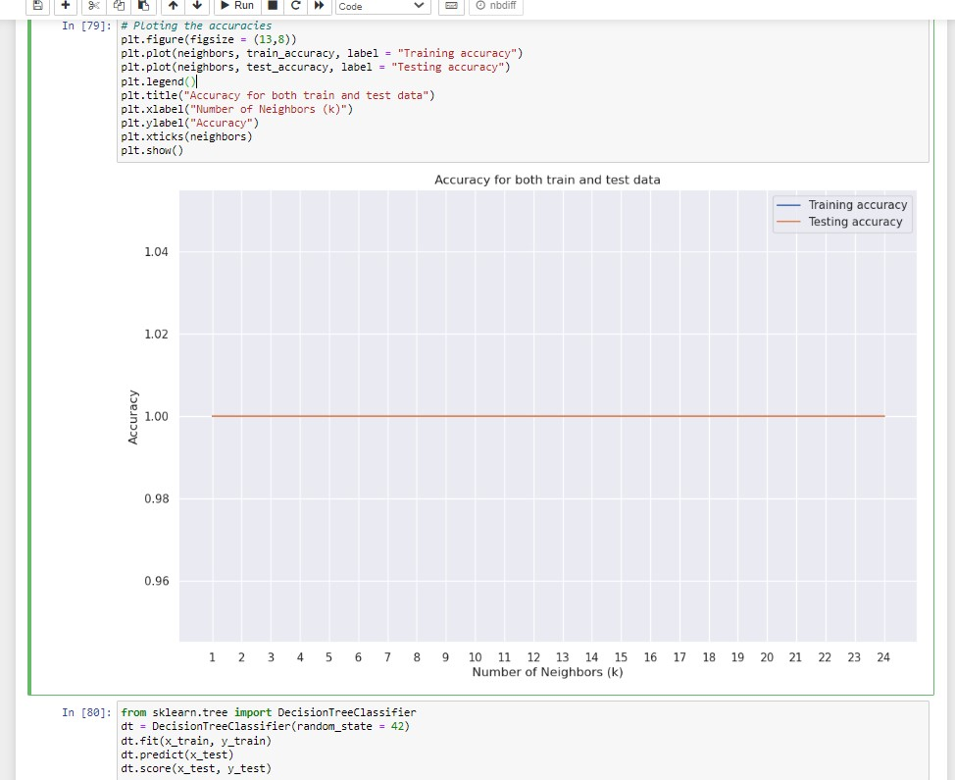

Decision Tree Classifier is another type of machine learning algorithm used for classification tasks. The accuracy of the decision tree classifier on the test data is 0.9761904761904762, which means that it correctly predicted the diagnosis of

97.6% of the patients in the test set.

# Conclusion

The method of forecasting disease based on symptoms weighted KNN model has the highest accuracy of 100% for disease. We could simply manage the medical resources required for treatment once the sickness was predicted. This concept would help to reduce the expense of treating the sickness while also improving the recovery process. The results show that the proposed system provides an accuracy of 100% which is higher than that of the other algorithm. It is highly believed that the proposed system can reduce the risk of chronic diseases by diagnosing them earlier and also reduces the cost of diagnosis, treatment, and doctor consultation.